CSE 546 - Bug Tracker - Project 2 Report
Raj Sadaye – 1213175416
Sachin Sundar Pungampalayam Shanmugasundaram – 1213230978
Satheesh Kurunthiah – 1212901792
Shubham Gondane – 1213179615

Problem Statement
The idea of the project is to create a project management system that will track the progress of projects. Each project will have several tasks and bugs during the development. This system helps the project lead and team members in creating a new task or a bug, the level of priority of them, to assign a team member who will be working on the task or bug. Each item can be tracked as backlog, to-do, progress, and resolved. Once completed, the project lead can review it and delete them or change the status. Whenever the CPU utilization exceeds, autoscaling should be triggered to start a new instance.

Design and Implementation

Architecture

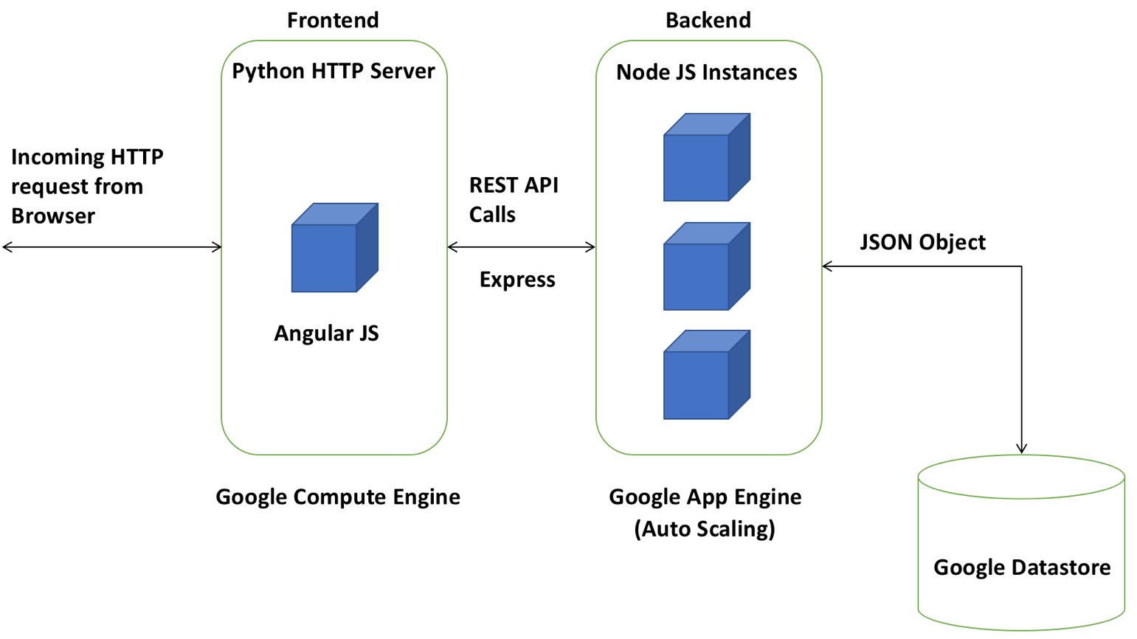

Description of components:

HTTP Requests:
Browser sends HTTP request to Frontend server and receives HTML content from server which is then rendered as User Interface.

Frontend
Python HTTP server is used to deploy the frontend server. Frontend as a whole is deployed on top of Google Compute Engine (Ubuntu 16.04). Frontend code is developed using Angular JS framework. Frontend Communicates with Backend via REST API Calls using Express framework.

Backend:
Node JS is used to develop Backend services. It is deployed on top of Google App Engine. Backend can be accessed using https://bugtracker-201402.appspot.com/ URL. Node JS instance is configured to auto scale of up to 20 instances.

Database:
Google Datastore is used as the database for this application. It is a NoSQL database and it is integrated with Google cloud environment which handles load balancing by its own. Backend communicates with datastore by passing JSON object between then asynchronously. Backend is not directly exposed Frontend.

Autoscaling
We are using existing feature of Google App Engine for the autoscaling. We have configured the CPU target utilization as 0.6. Whenever the CPU utilization reaches this threshold then Google App Engine automatically scales up another instance of Node JS. In the Backend code, server is configured to listen on ‘0.0.0.0’ port so that it will bind to the IP address in which it has been hosted. Google app engine will expose a public IP address that can be accessed by everyone which is https://bugtracker-201402.appspot.com/ . Internally when the instances go up or down it maps to the corresponding IP address and port number.

Testing and Evaluation
For testing locally, NPM from Node was used to deploy in localhost. In frontend NPM was configured to install dependencies in BOWER as well. Similarly, for local development of Backend server NPM was used to install dependencies. For database local development Google datastore emulator was used. This will create a local database and avoid get request which is charged on number of requests. We tested creating several users and projects for each user, assigning tasks, bugs to a user, changing the status of the tasks, deleting the tasks. Whenever the CPU utilization crossed 60%, autoscaling started a new NodeJS instance automatically and the flow of the application was not interrupted.

Code

Frontend:
Frontend code is organized as follows
- Scripts
  - Defines various states in application, transition across states and their corresponding templates
  - Defines all third-party components used in the application and their dependencies
- Services
  - For user sing in functionality, Firebase from Google Cloud is used. As of now users can only sign in using their Google account. This can be further extended to include all other sign in methods.
- Styles
  - All CSS code for UI can be found in this folder
- Views
  - Alert – Used to display results/error of an API call from backend
  - Create – Used to create new tasks in a project
  - Dashboard – Used to display various tasks in a project which can be drag and dropped to change their current status
  - Delete – Used to delete various tasks in a project
  - Header – Handles all functionalities that are provided via header
  - Project – Used to create new project and it is visible across users
  - Task – Used to add comments and edit tasks individually
- Index
  - Index.html file links all above components and external scripts included in Same Origin Policy. This page is served to browser whenever frontend is accessed.

Backend:
Backend code is organized as follows

- JavaScript
  - Project – This file handles API call to get all project and create new project in DB
  - User – This file handles API call to get all users and create new user in DB
  - Task – This file handles API call to get all task, get particular task, create new task, delete task, modify existing task and add comments to task.
- Services
  - DB – This file is used to communicate with Google Datastore asynchronously. Provides functionality for create, delete and modify data in database.
- Routes
  - /v1/get/tasks – GET – Returns tasks associated with user and selected project
  - /v1/get/comments – GET – Returns comments associated with task id
  - /v1/create/comments – POST – Create new tasks associated with user and selected project
  - /v1/add/comment – POST – Create new comment associated with task id
  - /v1/update/task – PUT – Updates tasks associated with user and selected project
  - /v1/delete/tasks – DELETE – Deletes list of tasks in a project
  - /v1/get/project – GET – Returns list of projects
  - /v1/create/project – POST – Create new project
  - /v1/get/user – GET – Returns list of users
  - /v1/add/user – POST – Add user to DB
- Server
  - This file has configuration to handle CORS request and links all above component. The server is configured to listen on ‘0.0.0.0’ port to allow deployment in Cloud environment

Database:
Database has following tables
- Project – This table stores project name, created by, and created time information
- User – This table stores user name and user email
- Task – This table stores task name, description, assignee, priority, project and comments

Project status
All required specifications in project description are met and working as expected.
- Requests are received via HTTP and Bug tracking service is provided via public IP address http://35.199.163.193/
- Frontend will interact with user and based on their input, content from backend will be served
- Backend will communicate with both frontend and database to server API call request
- Results are stored in google datastore

Individual contributions

5.1 Satheesh Kurunthiah – 1212901792

Responsibility
- Implement Frontend application that will handle incoming request from outside world and send the result as response
- Final integration of all 3 components (Frontend, Backend, Database) in Google Cloud

Design
During initial discussing for setting up of server that can handle request several methods like Node JS and python were discussed and finally Node JS is chosen to handle Backend because setting up of REST API calls is convenient and also integration into Google App Engine is very easy. For frontend should we use existing JADE as the engine to serve HTML content or should we use Angular JS was discussed and finally we decided to use Angular JS because it has more UI feature than other and also, we can get lot of open source build in functionalities. For database should we use Mongo DB, or should we use the Google Datastore as NoSQL database were discussed and finally Google datastore were chosen because datastore provides more storage space than Mongo DB for free of cost.

Pre-requisites
Python and GIT are the prerequisites that needs to be installed on the Google Compute engine in order to install deploy Frontend. Python’s in-built HTTP Server was used to deploy frontend code. For deploying backend on Google App Engine, app.yaml file has to be included in the repository. This file will have the information to auto scale. The cooling period for CPU is configured as 3 minutes and CPU target utilization is configured as 60 percent. Instances can span up to the count of 20. In order to access the database, credentials have to be created and its path has to be given as environment variable in deployed machine. For authentication in Firebase the deployed domain or IP address have to be given in order to allow incoming traffic from that IP address.

Implementation
Frontend, for each request will serve index.html from server from where it can transform into other states mentioned in above sections. It then waits until the request has been processed by backend and result is available. In order to allow incoming messages in Google Compute Engine security groups have to be added. This include Custom TCP which allows messages through port 80 from anywhere. Frontend is deployed in the server as services so that whenever an instance is launched the program start running without someone having to do it manually. In order to do this a script file is written which will automatically launch python HTTP server on system startup. This script has to placed inside /etc/init.d/ folder and its settings has to made to defaults by running update-rc.d command. This will make the script to run automatically when the system is booted. Backend is deployed to Google App Engine using GColud command line utility. Frontend server code will not have any external components. This has to be installed manually for first time using npm install command. Database doesn’t have to be deployed separately as it is by default in Google Cloud. We just have to set up credentials for accessing the database.

Testing
For testing Frontend locally NPM from Node was used to deploy in localhost. In frontend NPM was configured to install dependencies in BOWER as well. Similarly, for local development of Backend server NPM was used to install dependencies. For database local development Google datastore emulator was used. This will create a local database and avoid get request which is charged on number of requests.

